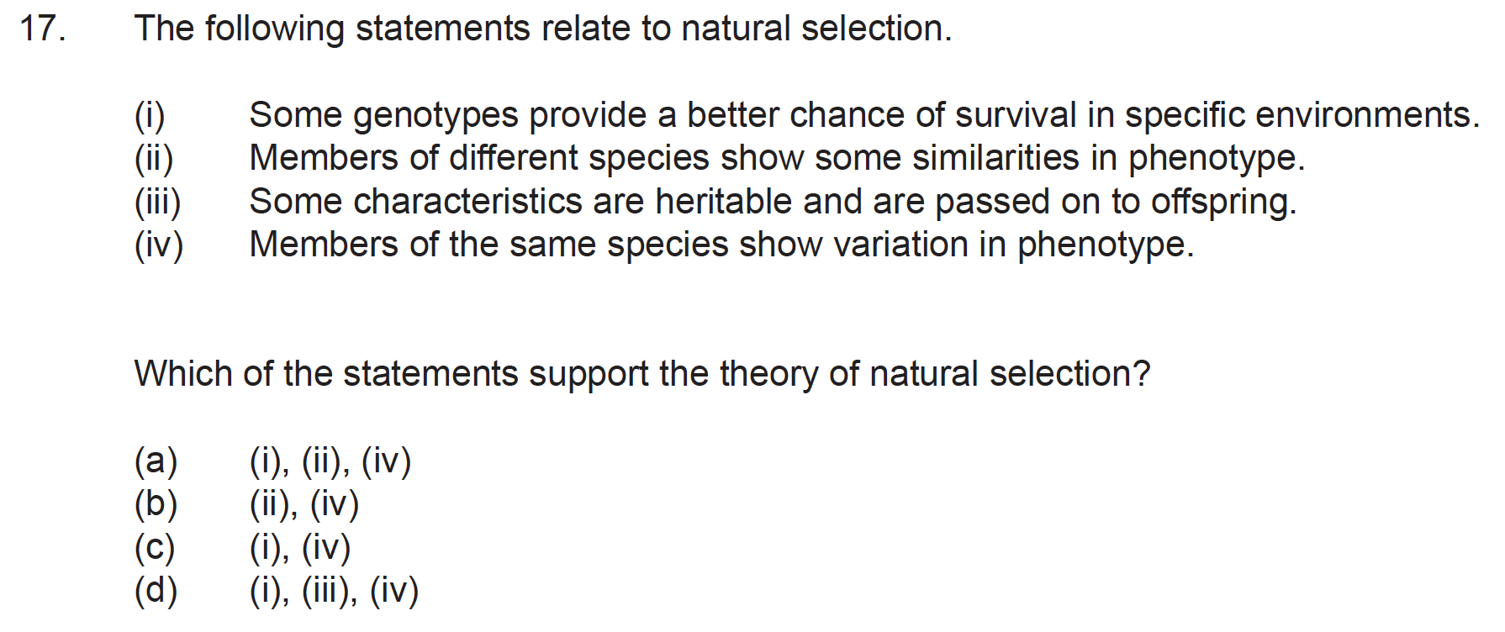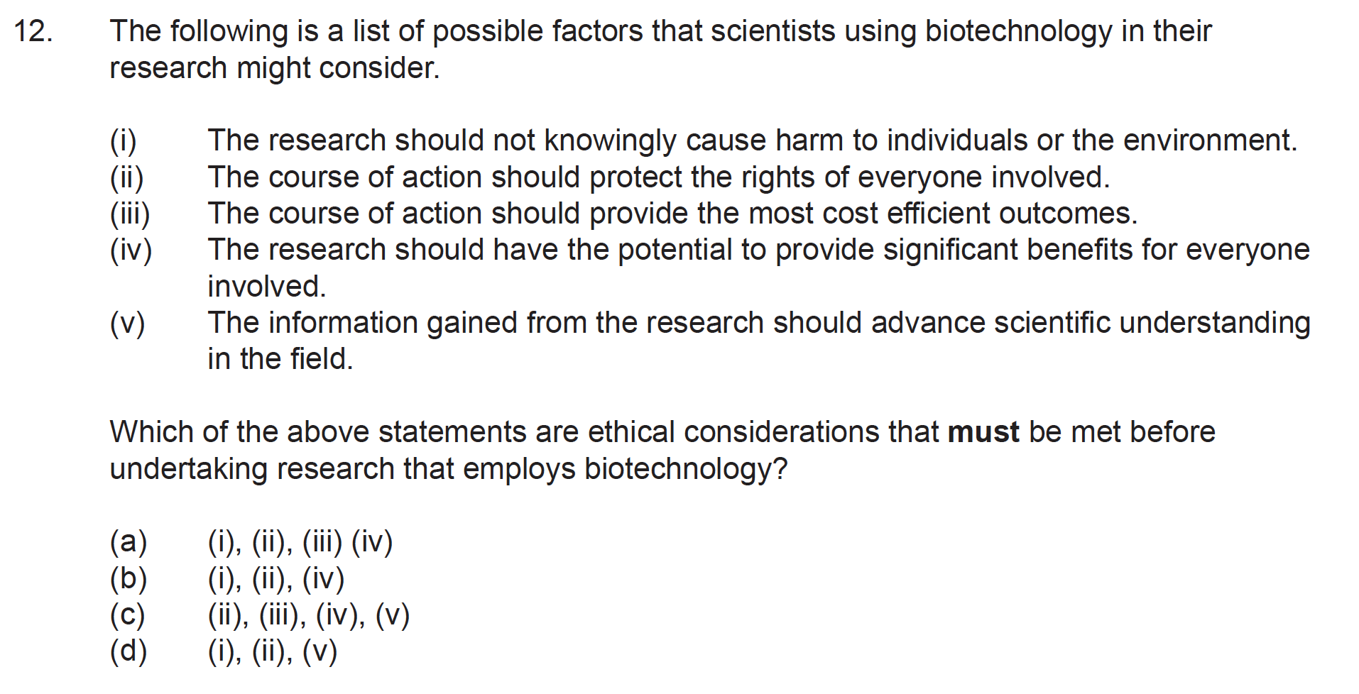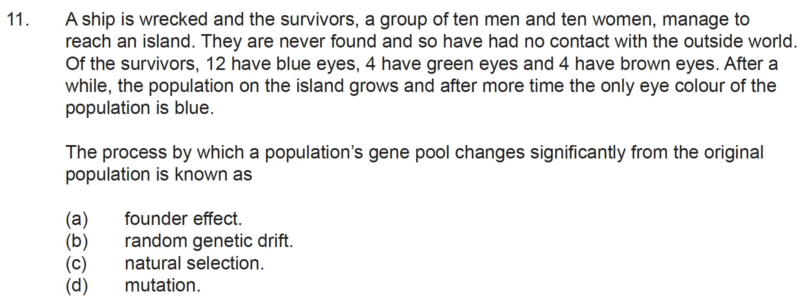**Mutations, Gene Pools, Biotechnology and Evidence for Evolution Exam Questions from the 2017 WACE Exam**

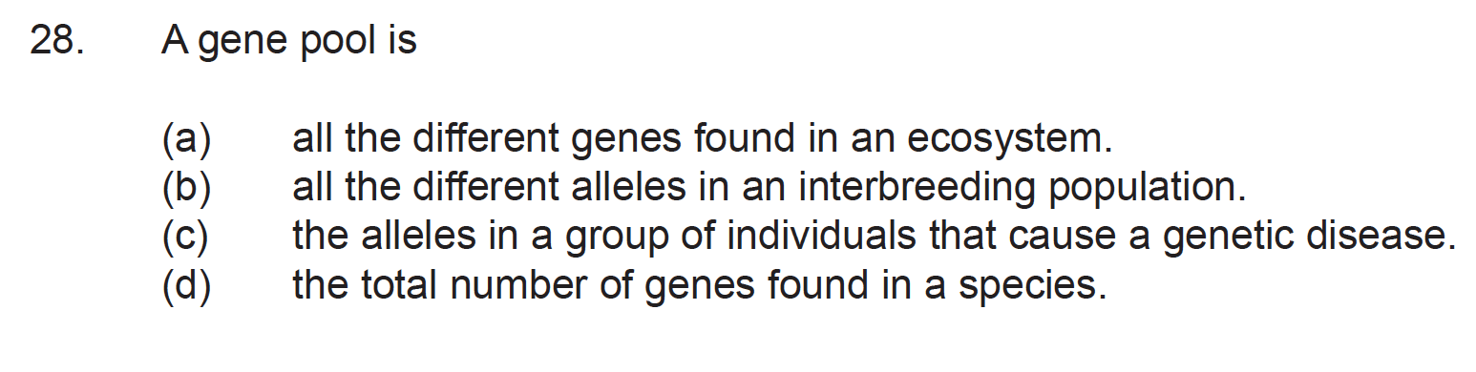

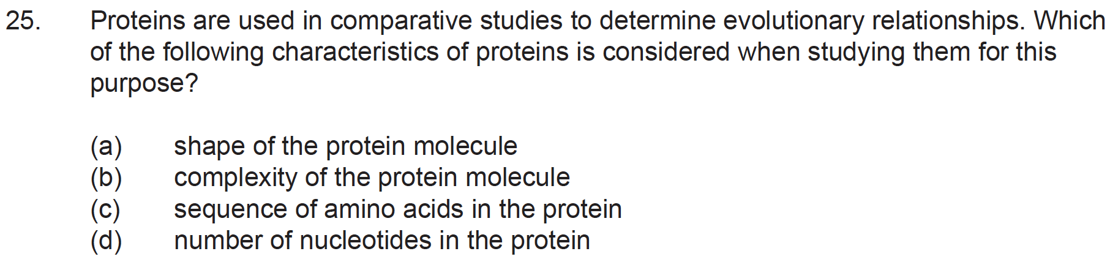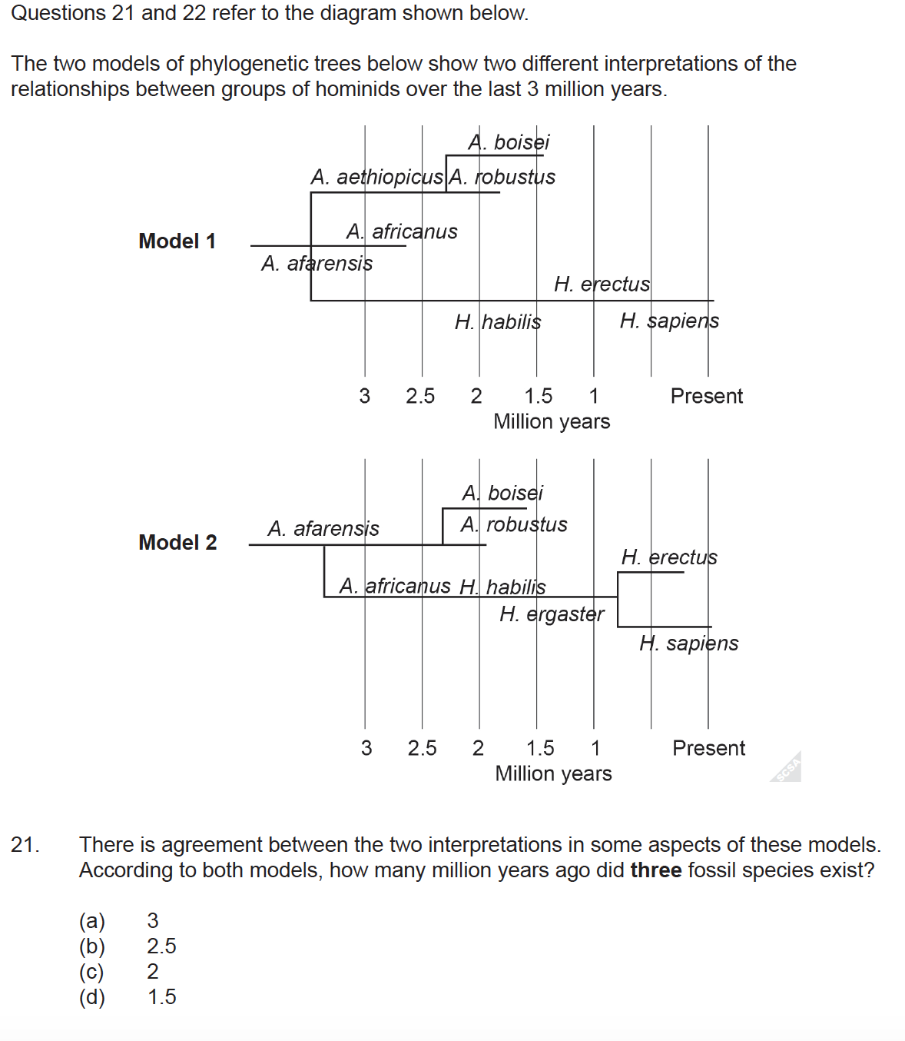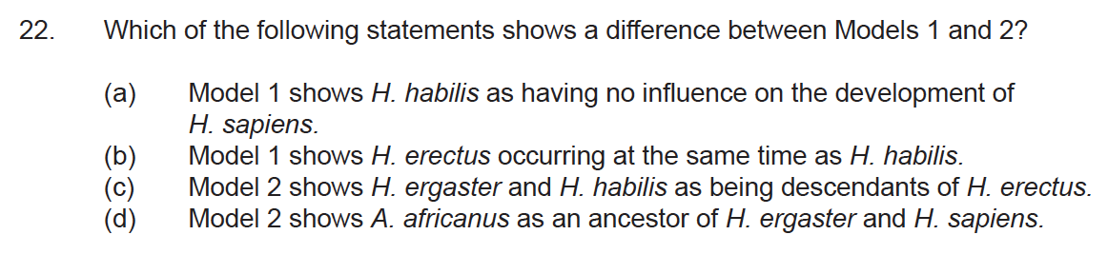

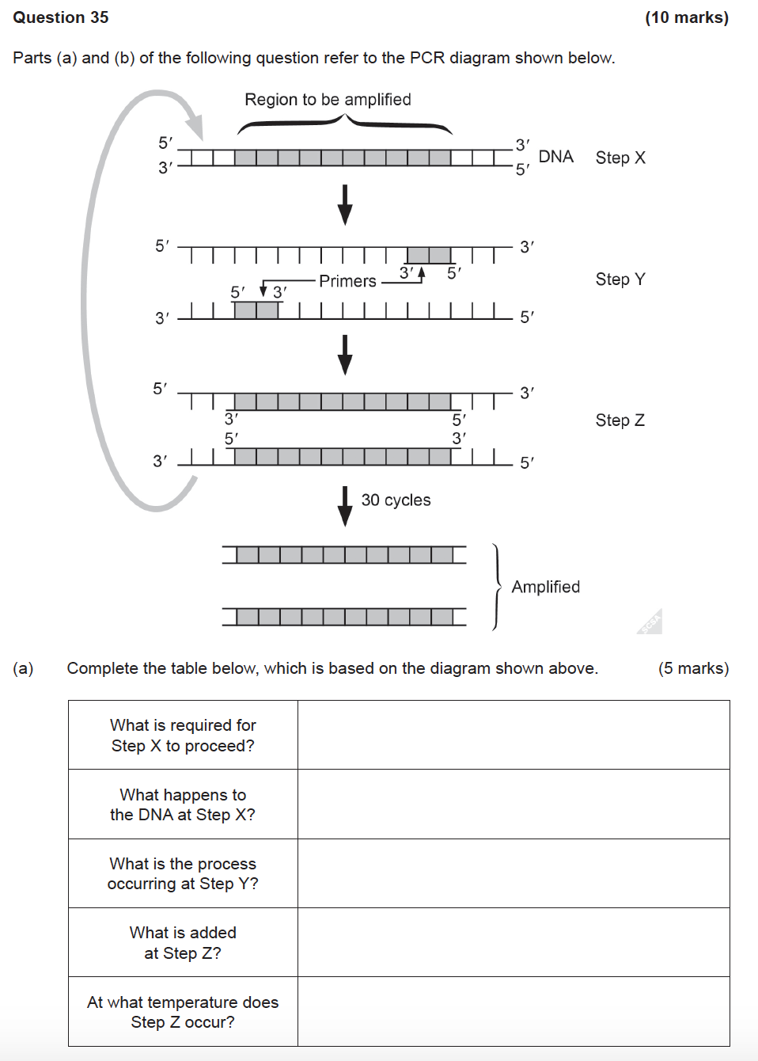



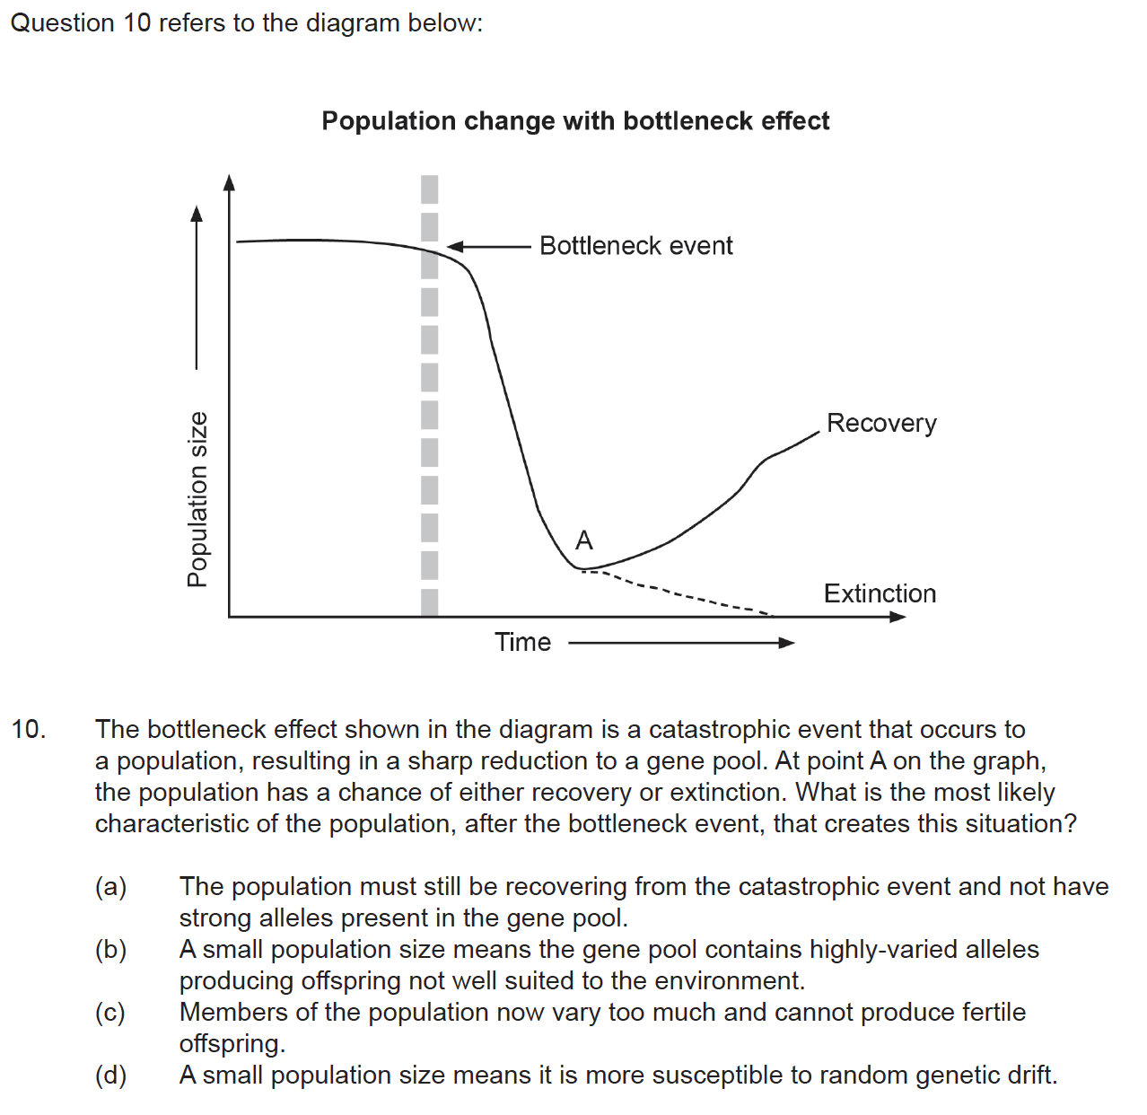 **Mutations, Gene Pools, Biotechnology and Evidence for Evolution Exam Questions from the 2018 WACE Exam**

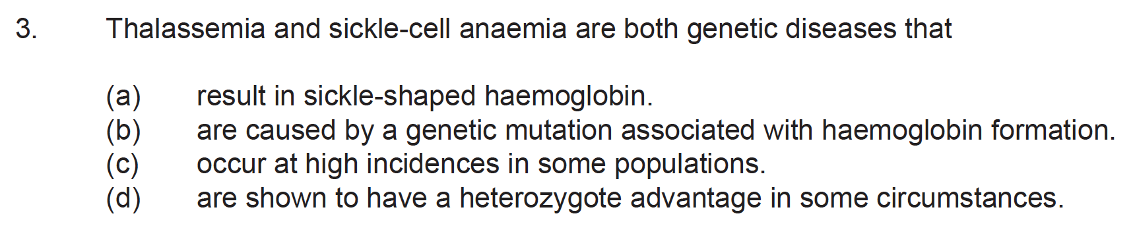

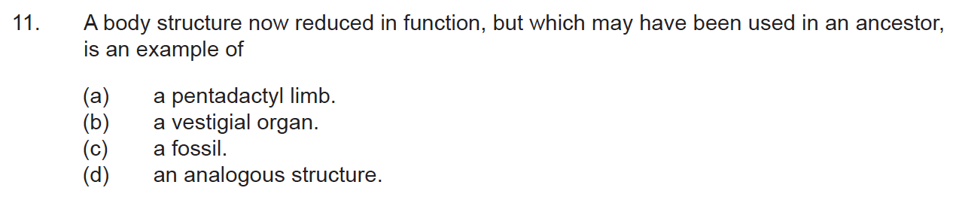

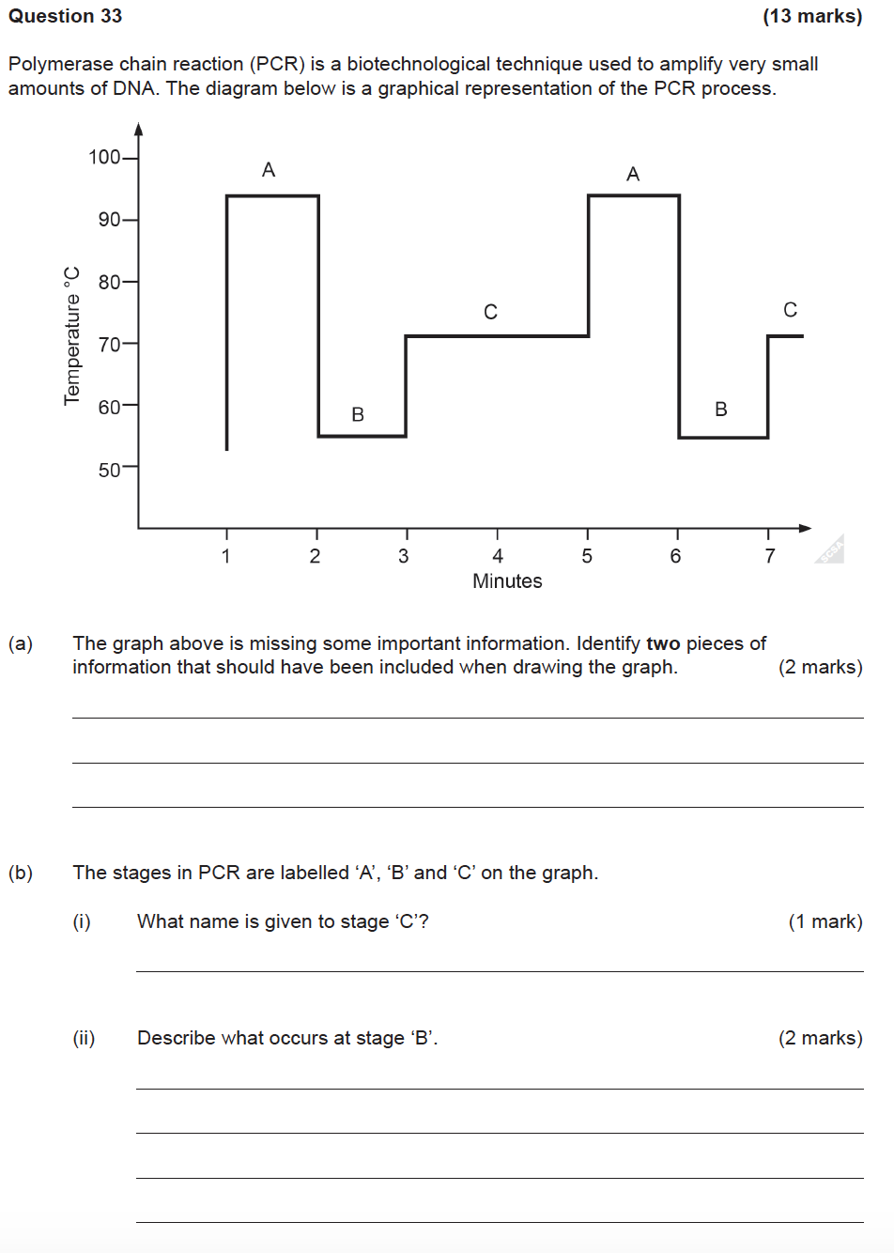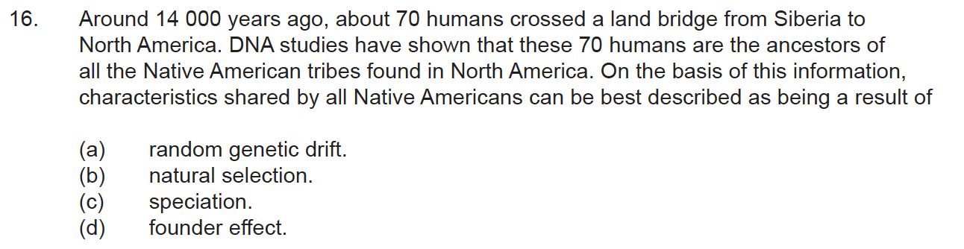

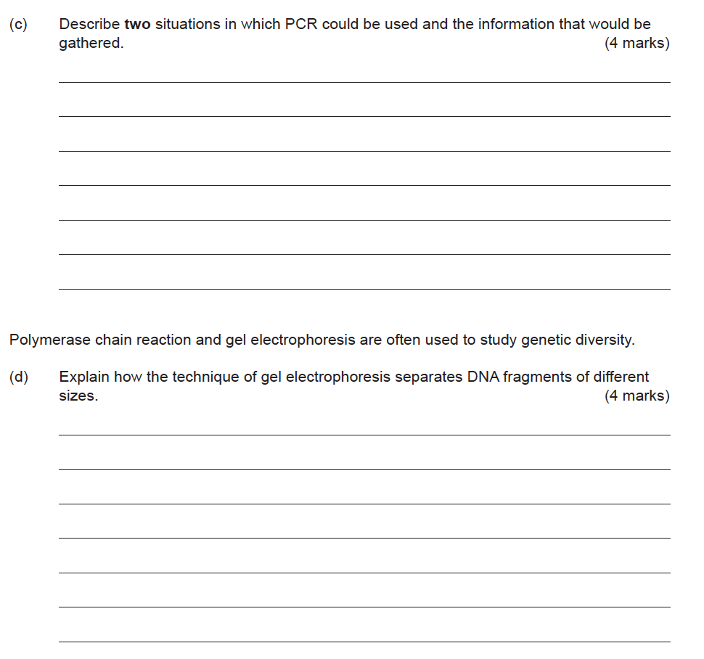

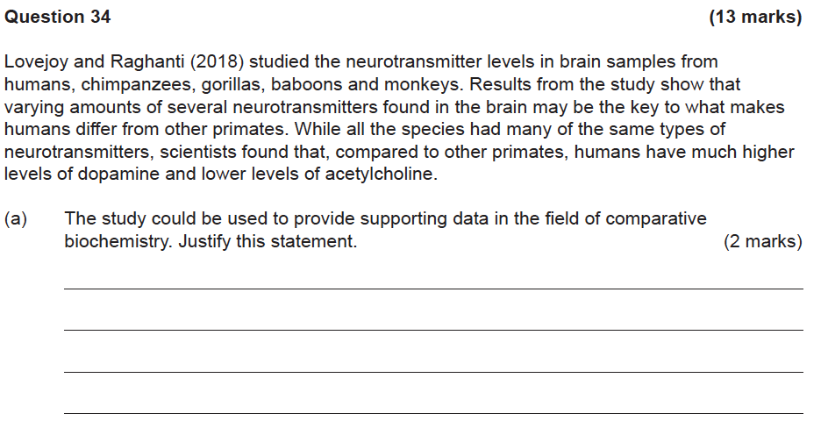

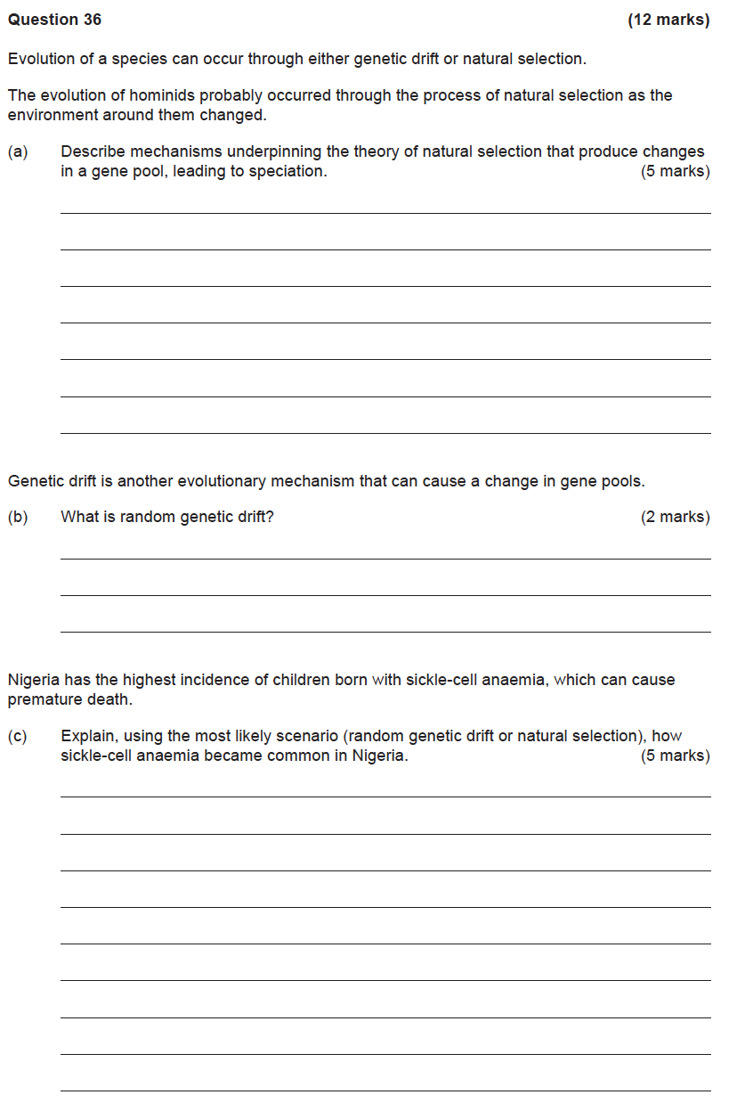

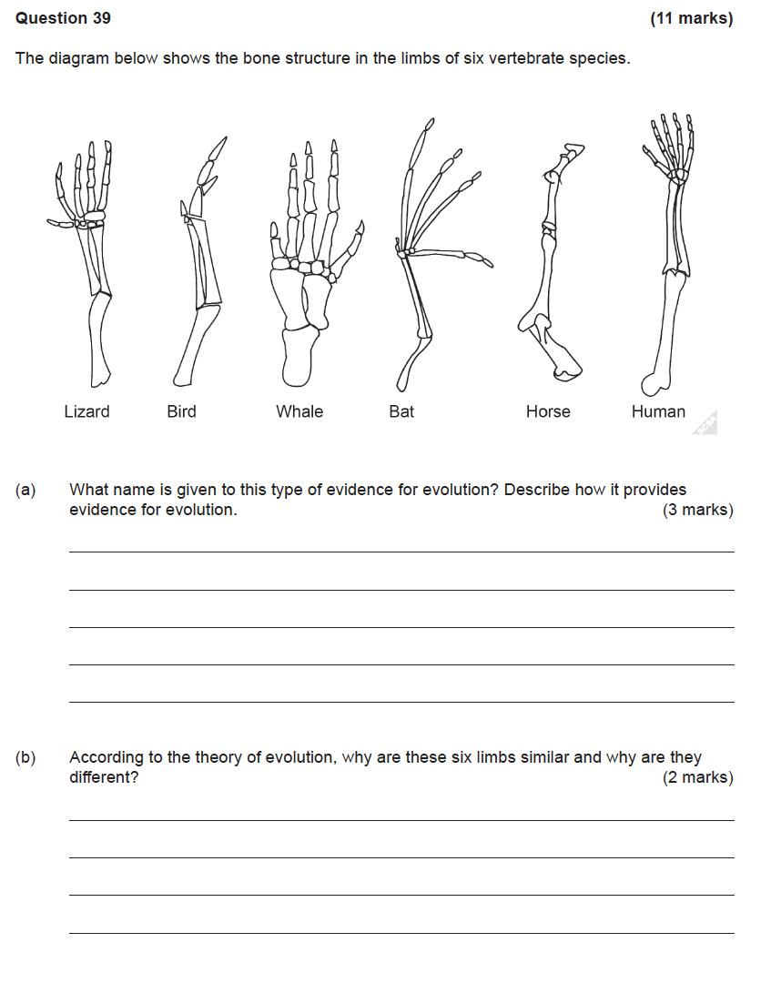

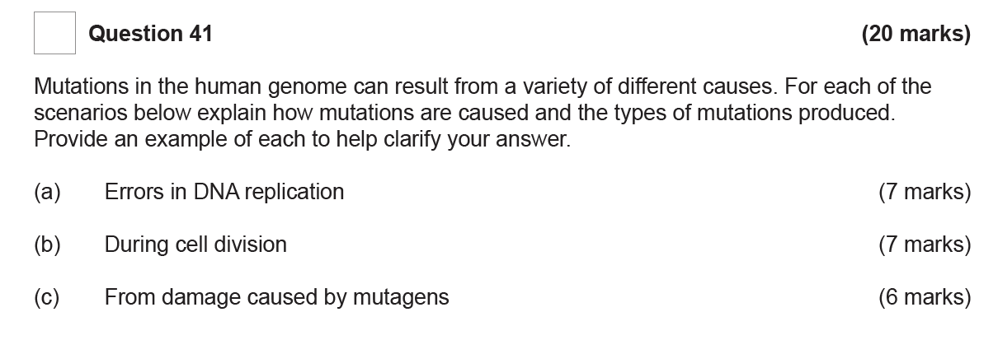

**Question 33 (16 marks)**

Tay-Sachs disease is a disorder of lipid metabolism which occurs as a result of a gene mutation. The recessive allele prevents the gene from producing a protein that will be able to function in the body. This recessive mutation is considered a `lethal recessive’. Tay-Sachs is unusually common in the Ashkenazi Jewish Community, an isolated group whose ancestors came from Nazi Germany during the War.

1. Distinguish between a gene mutation and a chromosomal mutation. (2 marks)
2. Justify why Tay-Sachs disease is considered a lethal recessive condition. (2 marks)
3. Using examples, explain how a lethal recessive mutation such as the Tay-Sachs disease can bring about changes in the gene pool through the two evolutionary mechanisms:
4. Founder Effect (3 marks)
5. Natural selection (3 marks)
6. Speciation can occur when evolutionary mechanisms underpinning the theory of evolution act on a gene pool. Comment on what these evolutionary mechanism are that result in speciation. (3 marks)

e. Comparative studies of DNA such as the study of Endogenous retroviruses (ERV’s) can provide evidence for speciation. Describe this method of comparative DNA analysis and discuss how it can provide evidence of speciation. (3 marks)

**Question 40 (20 marks)**

1. A minute sample of DNA has been obtained from an individual for paternity testing and to establish any possible link with a rare genetic disorder.

i. Outline two **named** techniques in biotechnology that are carried out as part of the process to DNA sequencing of the genome. Include why the two techniques are necessary to complete the DNA sequencing process. (8 marks)

ii. Rapid developments in genomic testing methods have made the sequencing of a person’s DNA faster and cost-efficient. Comment on some ethical issues involved in the use of the genomic information as a `lifetime health resource’. (3 marks)